Bitwise Manipulation

Definition
Bitwise manipulation means performing operations directly on the binary bits of integers.

Operators and Meaning
Operator | Name | Meaning | Example
& | AND | 1 only if both bits are 1 | 1101 & 1011 = 1001
| | OR | 1 if any bit is 1 | 0101 | 0011 = 0111
^ | XOR | 1 if bits differ | 0101 ^ 0011 = 0110
~ | NOT | Flip all bits | ~1010
<< | Left Shift | Multiply by 2^k | 5 << 1 = 10
>> | Right Shift | Divide by 2^k | 9 >> 1 = 4

Why Use Bitwise Operations
• Extremely fast (constant time)
• Saves memory using bit masks
• Eliminates extra data structures
• Useful for toggling, counting, grouping, checking states

Common Techniques
• XOR tricks
• Bit masking
• Shifting
• Counting set bits
• Bit DP

Benefits
• Low memory usage
• High performance for critical systems (OS, compilers, crypto)
• Avoids loops in some problems

Recognition Patterns
Look for problems involving:
• Unique element detection
• Power of 2 checks
• Counting bits
• Subset generation
• State compression (DP)
• Duplicate cancellation
• Binary representation tasks
• Turning flags on or off
• Very tight constraints (10^5 to 10^6 operations)

Steps to Apply
- Identify what each bit represents
- Choose the correct operator
- Use XOR for canceling duplicates
- Use masks for subset or state problems
- Optimize loops with Kernighan’s trick

Complexity
Time: O(n)
Space: O(1)

Important Bit Trick
Brian Kernighan’s Algorithm
Removes the lowest set bit each step:
while (x > 0):
x = x & (x - 1)
Counts set bits efficiently.

Bitwise XOR (Special Focus)
Definition
XOR outputs 1 only when the bits are different.

XOR Truth Table
A | B | A ^ B
0 | 0 | 0
0 | 1 | 1
1 | 0 | 1
1 | 1 | 0

Key Algebraic Properties
• x ^ x = 0 (self canceling)
• x ^ 0 = x
• Commutative: a ^ b = b ^ a
• Associative: (a ^ b) ^ c = a ^ (b ^ c)
• (a ^ b) ^ a = b
These properties make XOR powerful for array problems.

Uses / Applications
• Remove duplicates
• Find unique element
• Swap without extra variable
• Parity tracking (even or odd frequency)
• Missing number detection
• Faster than hashing in some cases

Types of XOR Problems
• Simple XOR
• Bit counting + XOR
• Index based XOR
• Prefix XOR
• XOR DP

Benefits
• O(1) space
• No extra memory like hash maps
• Very fast bit level operation
• Clear mathematical properties

Recognition Patterns
Clues that XOR is needed:
• One element appears once, others twice or thrice
• Find missing number
• Pair cancelation
• Toggle states
• Parity problems
• Subarray XOR queries
• Binary parity comparison

Standard Approach
- Initialize result = 0
- XOR all elements
- Use result to determine unique or missing value
- If multiple uniques exist, split using a distinguishing bit

Important LeetCode Problems (Bit Manipulation)
Easy
• 136 Single Number
• 191 Number of 1 Bits
• 231 Power of Two
• 268 Missing Number
• 190 Reverse Bits
• 461 Hamming Distance
• 693 Binary Number with Alternating Bits

Medium
• 137 Single Number II
• 260 Single Number III
• 201 Bitwise AND of Numbers Range
• 389 Find the Difference
• 421 Maximum XOR of Two Numbers
• 1310 XOR Queries of a Subarray
• 1486 XOR Operation in an Array

Hard
• 982 Triples with Bitwise AND Equal To Zero
• 1707 Maximum XOR With Element From Array
• 1803 Count Pairs With XOR in Range

Bitwise Manipulation (Visual Guide)
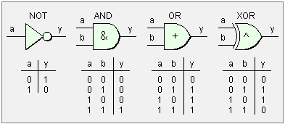

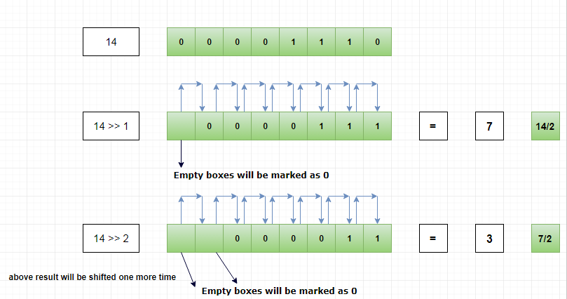
4
What the visuals show
1. AND (&)
Keeps only common 1 bits
Useful for masking and checking bits
1101
& 1011
------
1001

2. OR ( | )
Sets bit to 1 if any input bit is 1
0101
| 0011
------
0111

3. NOT (~)
Flips all bits
~1010 → 0101 (ignoring sign details)

4. Left Shift (<<)
Moves bits left, fills with 0
Equivalent to multiplying by 2^k
5 = 00000101
5 << 1 → 00001010 = 10

5. Right Shift (>>)
Moves bits right
Equivalent to dividing by 2^k
9 = 00001001
9 >> 1 → 00000100 = 4

6. Bit Masking
Turn ON a bit:
x | (1 << k)
Turn OFF a bit:
x & ~(1 << k)
Toggle a bit:
x ^ (1 << k)
Check a bit:
x & (1 << k)

Bitwise XOR (Visual Guide)

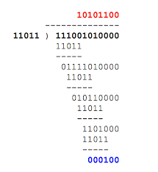
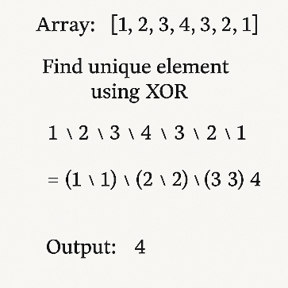
4
XOR Truth Table
A B | A ^ B
0 0 | 0
0 1 | 1
1 0 | 1
1 1 | 0
Think: XOR = Different → 1, Same → 0

Self-Canceling Property
x ^ x = 0
Example:
1011
^1011
-----
0000

Unique Element Trick
Array: [2, 3, 2, 4, 3]
2 ^ 3 ^ 2 ^ 4 ^ 3
= (2^2) ^ (3^3) ^ 4
= 0 ^ 0 ^ 4
= 4
All duplicates cancel out.

Swap Without Temp Variable
a = a ^ b
b = a ^ b
a = a ^ b

Missing Number Pattern
XOR all indices and values:
(0 ^ 1 ^ 2 ^ 3 ^ 4) ^ (array elements)
Duplicates cancel → missing remains.

Subarray XOR (Prefix Trick)
prefix[i] = a1 ^ a2 ^ ... ^ ai
XOR of subarray (L, R):
prefix[R] ^ prefix[L-1]

